UNICEF KIDS BAND FIRMWARE UPGRADE INSTRUCTIONS
- Pls scan QR to set up the firmware upgrade app (固件升级6.25） in your iPhone 4S on or above.
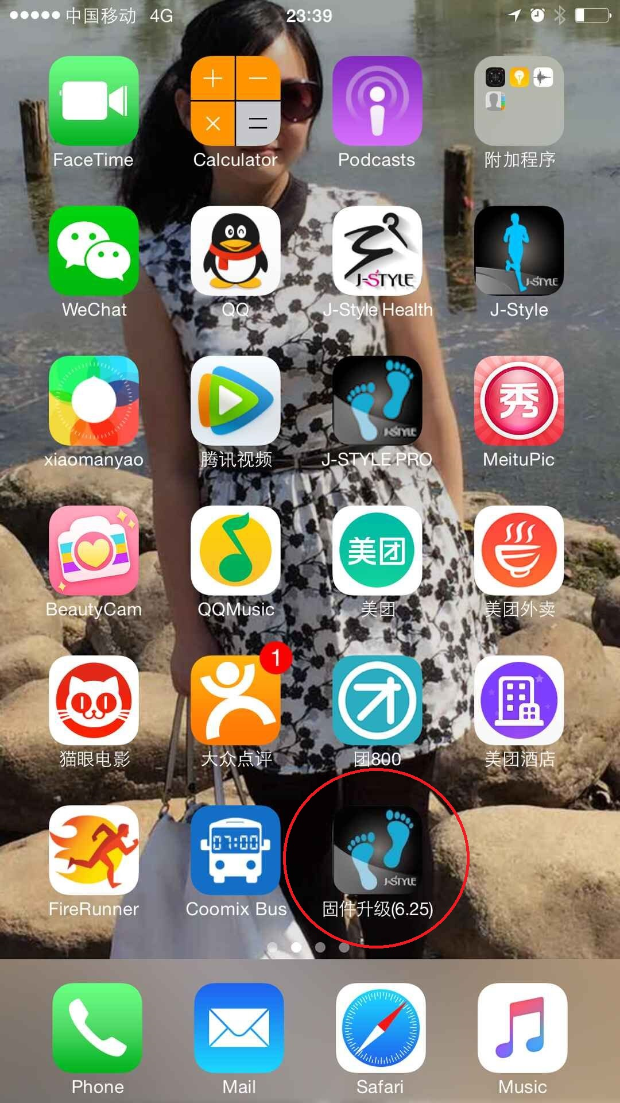

- Pls connect with PC and use iTunes to add the whole zip file with name J083 V102 20150821 01. into the firmware upgrade app (固件升级 6.25）, and sync it. then disconnect it with PC. (Pls don’t unzip the zip file)

- Open the app from iPhone desktop and you can see below page.

4, click SELECT FILE to select the file J083 V102 20150821 01.
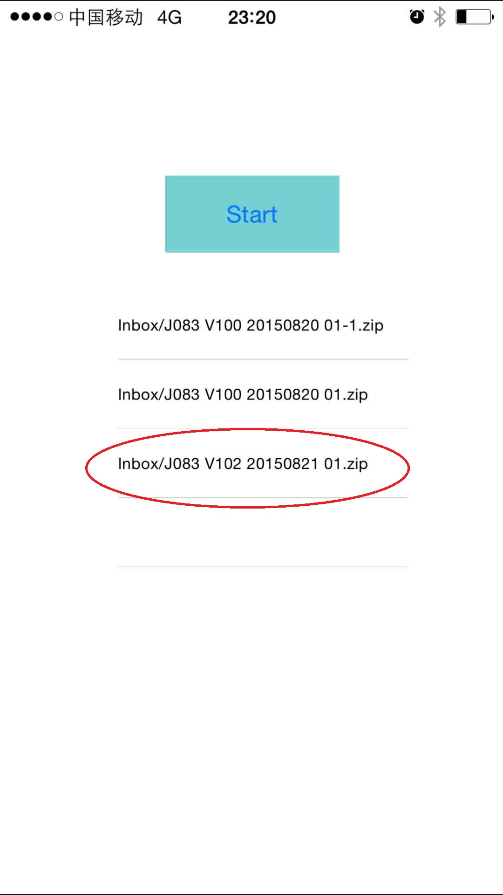

5. Then click START to search and connect your device and it will upgrade itself immediately.
After upgrade finished, you can see your devices will display UNICEF KID POWER.
